 | DEPARTMENT OF COMPUTER ENGINEERING
Experiment No. 3A
Semester | T.E. Semester VI
Subject | ARTIFICIAL INTELLIGENCE (CSL 604)
Subject Professor In-charge | Prof. Avinash Shrivas
Assisting Teachers | Prof. Avinash Shrivas

Student Name | Deep Salunkhe
Roll Number | 21102A0014
Lab Number | 310A

Title:

Mathematical solution to Water jug problem

Theory:

- The gcd function calculates the greatest common divisor of two numbers, which is used to check if it's possible to measure out the desired quantity of water using the given jug capacities.
- The ispossible function checks if it's possible to measure out the desired quantity of water using the given jug capacities and the finalx quantity.
- The fillx function fills the first jug to its maximum capacity.
- The emptyy function empties the second jug.
- The transfer_x_to_y function transfers water from the first jug to the second jug until the second jug is full or the first jug is empty.
- In the main function, the user inputs the capacities of the two jugs (xcapacity and ycapacity) and the desired quantity of water (finalx). It then checks if it's possible to achieve the desired quantity of water with the given capacities using the ispossible function.
- Finally, when the desired quantity is achieved, the program prints "congratulation" and terminates.

Program Code:
#include<iostream>
using namespace std;

int gcd(int x,int y){

if(y==0)
return x;
else
return gcd(y,x%y);
}

bool ispossible(int x,int y,int d){
int valgcd=gcd(x,y);
if(d%valgcd==0)
return true;
return false;
}

void fillx(int &xState,int &xcapacity){
xState=xcapacity;
}

void emptyy(int &yState,int ycapacity){
yState=0;
}

void transfer_x_to_y(int &xState,int &yState,int &xcapacity,int &ycapacity){

int y_can_take=(ycapacity-yState);
if(y_can_take>=xState){
yState=yState+xState;
xState=0;
}else{
xState=xState-y_can_take;
yState=ycapacity;

}
}

int main(){

int xcapacity,ycapacity,finalx;
int xState=0,yState=0;
bool possible=true;
cout<<"Enter capacity for first container"<<endl;
cin>>xcapacity;

cout<<"Enter capacity for second container"<<endl;
cin>>ycapacity;

cout<<"Enter Final state of first container"<<endl;
cin>>finalx;

possible=ispossible(xcapacity,ycapacity,finalx);
if(!possible){
cout<<"Not possible"<<endl;
return 0;
}

cout<<"X"<<" "<<"Y"<<endl;

while(xState!=finalx){
if(xState==0){
fillx(xState,xcapacity);
}else if(yState==ycapacity){
emptyy(yState,ycapacity);
}else{
transfer_x_to_y(xState,yState,xcapacity,ycapacity);
}

cout<<xState<<" "<<yState<<endl;
if(xState==finalx || yState==finalx ){
cout<<"congratulation"<<endl;
return 0;
}

}

return 0;
}

Output:

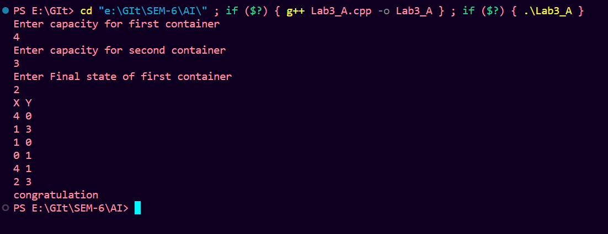

Conclusion:

The provided code effectively tackles the Water Jug Problem, employing fundamental programming constructs like conditionals, loops, and functions. It illustrates the application of mathematical concepts, such as the greatest common divisor, in solving real-world problems through programming. By simulating the pouring of water between jugs until the desired quantity is achieved, the code demonstrates problem-solving techniques and reinforces programming proficiency. This lab exercise serves as a practical example for understanding problem-solving methodologies

